Retail Analytics For Supermart Stores For The Year 2015 To 2018

Outline

Introduction

Story of Data

Data Splitting and Preprocessing

Pre-Analysis

Post-Analysis and Insights

Data Visualization and Charts

Recommendations and Observations

Conclusion

References & Appendices

Introduction:
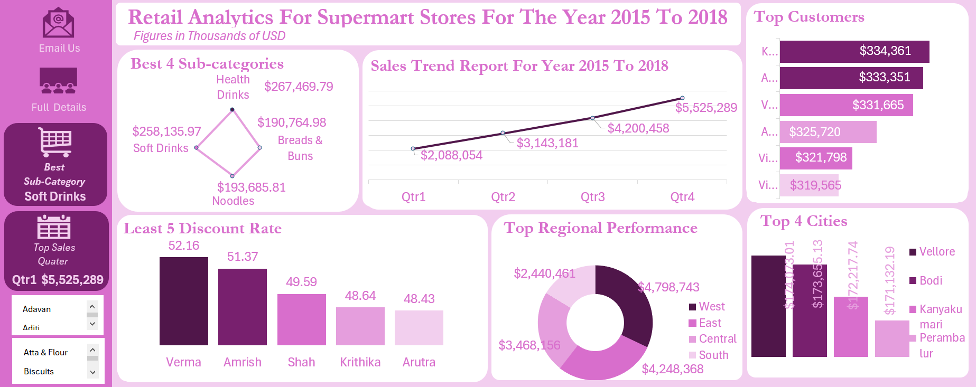

-Project Objective

The major aim and objective for this analysis is to analyze the retail of food categories and sub-categories purchased by various customers within various cities of operation and their regions from year 2015 to 2018. This analysis further aims at helping the stakeholders of this project to make data-driven decisions that will yield greater revenue for the business.

This project aims at addressing and answering these questions:

Top Retail Customers from 2015 to 2018.
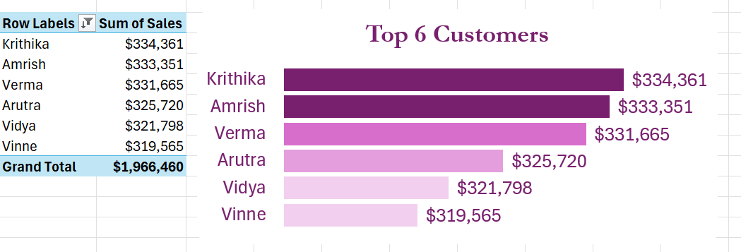

Fine tune out the best sub-categories.
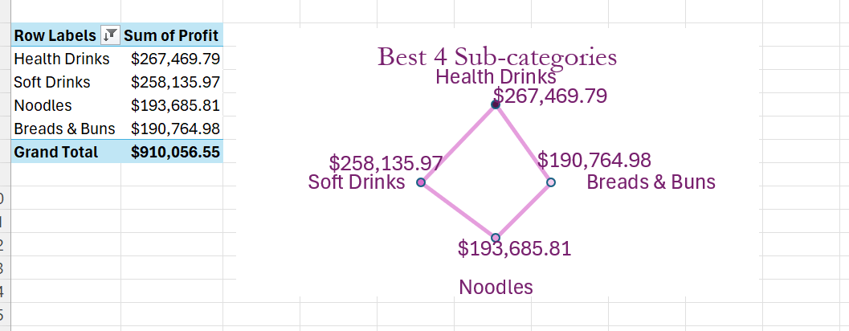

Ascertain the performance of each region.
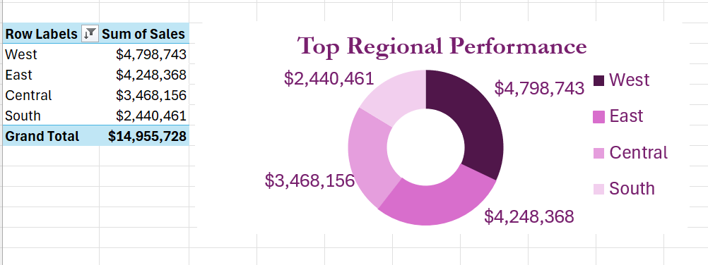

Find out customers with the least discount rates.
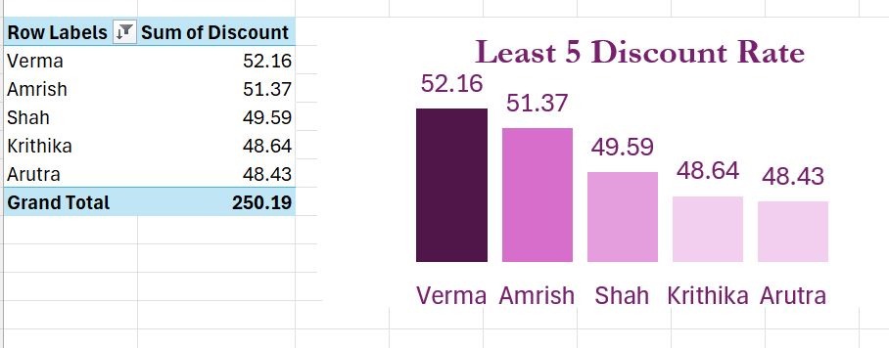

Sales Trend Report
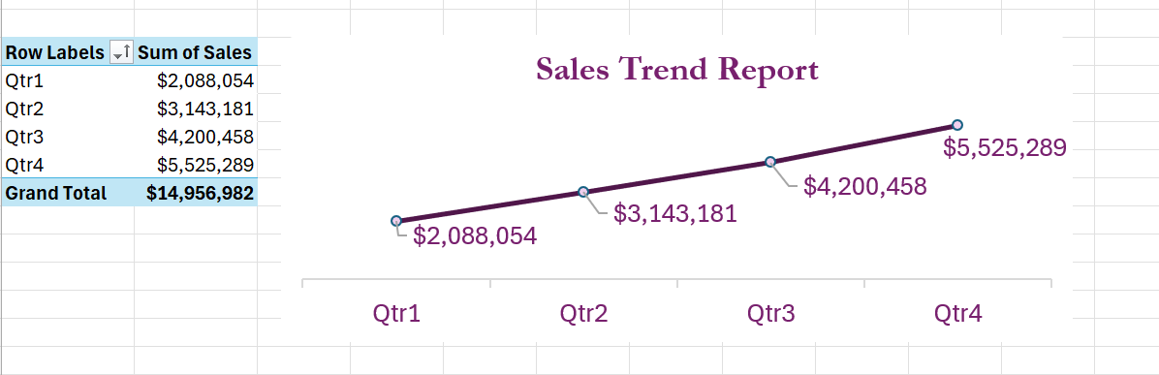

Top cities by the revenue they generated.
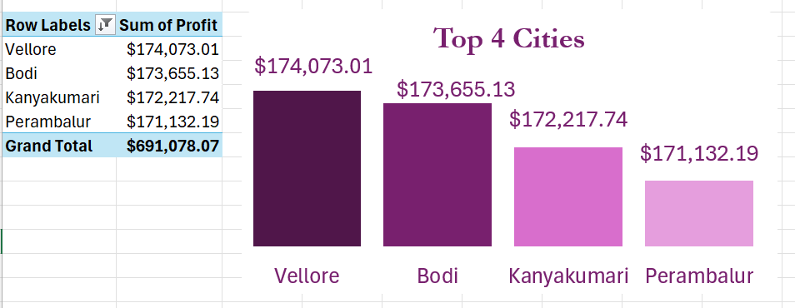

The major dataset used for this analysis is Sales Data. The key methodology used is Microsoft Excel and the Pivot table in Microsoft Excel was the major tool used to address and answer all of the project questions

Story of Data:
The dataset is a public dataset available for public consumption. The dataset was downloaded from kaggle.com and it has a total number of 9994 rows and 11 columns.

The dataset is structured in columns and rows. The columns contain variables, both Dependent and Independent Variables. And the rows contain the data points and transactions.

The analysis includes Sales, Profit and discount rate as the key outcome variable and other variables such as Customer Name, Category, Sub-Category, City, Order Date, Region, and State. These variables contribute immensely to this analysis as they are key factors to addressing and answering questions from the project.
The limitations and biases encountered with the dataset were empty columns.

Data Splitting and Preprocessing:
-Data cleaning
I got the dataset downloaded from kaggle.com and uploaded it into my Excel Workbook for further analysis. Basic checks and observations were made in the dataset to ensure it was clean and consistent for analysis. Checks for duplicates, empty cells, inconsistencies in letter casing and spacing were made and corrected. To retain the raw dataset for another use, I had to duplicate the dataset and use one for the analysis.

Data Splitting:
The dataset was split into two variables namely, Dependent Variables and Independent Variables.

-Independent Variables
1. Customer Name
2. Category
3. Sub-category
4. City
5. Region
6. State
-Dependent Variables
1. Sales
2. Discount
3. Profit

Industry Context and Stakeholders:
The dataset shows the retail analytics of Supermart Grocery Store from 2015 to 2018. A list of their customers, their product categories and sub-categories. It further tells the prices for each category sale, the discount given to each customer and the profits made. The major stakeholders for this project are the auditors and the sales managers.
Generating more profits despite the discounts given to customers, is exactly what success means to Supermart Grocery Store.

Pre- Analysis:

-Potential Questions
1. Customers performance by sales
2. category performance by sales
3. Highest category by profit
4. Performance of regions by sales
5. Best state by profits generated
6. Discount rate for each customer name
7. Best sub-category by profit generated

-Potential Insights
1. Finetune out the best performed customers and establish ways to retain them.
2. Ascertain the most purchased category and ensure they remain on-stock and available for customers.
3. Finetune the categories that generate more profits and adopt means of making those categories readily available and accessible always.
4. Finetune out the regions that performed well and ensure that retail services there are up to standard.
5. Ascertain regions that are not generating expected profits and look out for best measures to increase their profit generation.
6. Finetune out the states that have performed well and make sure they keep up with their patronage.
7. To ascertain customers with highest and lowest discount rates and know how to regulate them.
8. Ascertain the most performed sub-categories and discover methods to further increase the profits they generate.

Data Visualization:
1. Top 6 Customers
2. Best 4 Sub-Categories
3. Top Regional Performance
4. Sales Trend Report
5. Least 5 Discount Rate
6. Top 6 Cities

In-Analysis Observations:

-ANALYSIS- Top 6 Customers
1. The sales generated from Krithika topped other customers by $334,361, making them the store's best customer from 2015 to 2018.
2. Krithika and Verma generated slightly close sales within these years. Krithika generated $334,361 whileVerma generated $331,665.
3. Vinne generated the least sales by $319,565.

-ANALYSIS- Best 4 Sub-Categories
1. Health drinks generated lots of profits for the store than other sub-categories. It generated a total of $267,469.79 from 2015 to 2018.
2. Breads & Buns generated the least profit for the store. It generated a profit of $190,764.98 as most customers don't purchase them.

ANALYSIS - Sales by Product Category
- Beverages topped other product categories by generating $110,577.11 for the year 2014.
- Canned meat has the lowest sales with a poor revenue of $25,465.60.
- Dried fruit and nuts also didn't have good sales for the year 2014 ,as it generated a poor revenue of $27,999.50.

-ANALYSIS- Least 5 Discount Rate
1. Of over 1,000 customers of Supermart stores from 2015 t0 2018 these customers have been given low discounts in all of their purchases and the companies are;Verma, Amrish, Shah, Krithika, and Arutra.
2. Among the customers with the lowest discount rate, Arutra was given the lowest discount at 48.43%.

-ANALYSIS- Top Regional Performance
1. The Western region generated a total sale of $4,798,743 for the store from 2015 to 2018 above other regions.
2. The Eastern region also made lots of purchases from the store within these four years that generated $4,248,368 for the store.
3. The Southern region performed poorly during the years of 2015 to 2018 with discouraging sales of $2,440,461 .

-ANALYSIS- Sales Trend Report
1. Within the first quarter of the four year analytics, sales were very slow and low by $2,088,054, thereby affecting the store's profit immensely.
2. Sales increased immensely by $5,525,289 in the fourth quarter of the four years and this resulted in an increase in profit.
3. The second and third quarter experienced a close relationship in sales by $3,143,181 and $4,200,458 respectively.

-ANALYSIS- Top 6 Cities
1. Vellore city generated the highest profit of $174073.01 for the store within the years of 2015 to 2018.
2. Bodi city generated a profit of $173655.13 while Kanyakumari city generated a profit of $172217.74. thereby sharing a huge similarities in their profits generated.
3. Karur city and Tirunelveli city generated very low profit for the store within these four years with a profit of $169,305.94 and $165,169.01 respectively.

In-Analysis Insights:

-ANALYSIS- Top 6 Customers
1. salespersons and marketers should concentrate more on customer Krithika, so as to retain their increasing patronage.
2. A bonus or promo package can be put in place to further boost the morale of customer Verma to enable them to increase their patronage.
3. Observations should be carried out to ascertain the reasons for the decrease in purchases from customer Vinne.

-ANALYSIS- Best 4 Sub-Categories
1. Since most customers purchased lots of health drinks within these years because of its health benefits, It is necessary to always stock it up and ensure the prices are affordable.
2. Findings should be carried out as to why most customers don't purchase bread and buns from the store. If it is a matter of quality, then the quality of these sub-categories should be increased to enable more profit generation.

-ANALYSIS - Sales by Product Category
1. Understand why low discounts were given to these customers and ensure their patronage to the store is worth it.
2. Customer Aruta's discount rate should be considered for increase, as the store's aim is to make profit.

-ANALYSIS - Top Regional Performance
1. The sales patterns and methods used in the Western region can be adopted by other regions, especially in the Southern region.
2. More advertising of supermart categories and sub-categories can be done in the Eastern region to attract more customers and more sales.
3. Dedicated and hardworking salespersons from the Western region can be transferred to the Southern region for effective change and sales optimization.

-ANALYSIS - Sales Trend Report
1. An audit can be made to ascertain the reason for such low sales within the first quarter of the four years of analytics and corrective measures taken to effect change.
2. Observations can be made to finetune out the propeller for such huge sales in the fourth quarter and adopt these methods in the other quarters.
3. Bonuses could be given to customers within the second and third quarter of the year to motivate them further.

-ANALYSIS- Top 6 Cities
1. Larger product categories and sub-categories should be readily available as it generates much profit for the store.
2. Salespersons in Bodi city and Kanyakumari city can be sent for further training and mentorship.
3. Prices of categories and sub-categories can be minimized to attract more customers within the cities of Karur and Tiranelveli.

Post-Analysis Observation:

1. Customer Adavan who topped the other customers is from Bodi city in the Western region . The customer purchased more goods from the store during the fourth quarter of the four years. The sub-categories he purchased more were health drinks, organic vegetables, chocolates, and soft drinks with a discount of 52.16% in all.
2. A total of $503 sales was made in the Western and Southern region from 2015 to 2018. The sub-categories that sold more within these regions were fresh fruits, soft drinks, and chocolates. Madurai, Perambalur, and Viluppuram cities generated most of these sales. The customers for the generation of this sales were customer Muneer, Shah, and Roshan
3. The central region generated $3,468,158 profit for the store throughout the four quarters. They sold more Noodles, Health drinks, Soft drinks, and Chocolates. The major customer for this region is customer Vidya with a discount rate of 14% for all purchases and their major cities of sale are Vellore and Bodi city.
4. The sub-category bread and buns did not sell much in the first and second quarter of the four years despite the low discounts of 3.45% and 3.38% respectively given to the main customers of this sub-category. The sub-category was sold in all the regions but was mostly purchased by customers Amrish and Arutra from Perambalur and Bodi City .

Post-Analysis Recommendation:
1. I recommend that a questionnaire should be issued out to all customers of the store in different regions to ascertain their views and complaints about the Grocery store. And corrective and more strategic measures should be taken to get more of their patronage and meet customer satisfaction, so that customer Adavan wouldn't be the only top and outstanding customer in the following years.

2. A studying and understanding of what sub-category the Southern and Western regions prefer more or would like to purchase should be carried out and the store can make sure those sub-categories are within their reach and at affordable prices.
3. More intense advertising and awareness of the Grocery store and the affordable product categories and sub-categories it offers should be made at the central region to enable higher profit generation from this region.
4. I recommend that the quality of the sub-category bread and buns be upgraded and bonuses and sales benefits should be placed on them in all regions so it generates more sales and profits.

Conclusion:
The Retail Analytics For Supermart Stores for 2015 to 2018 shows the retail of product categories and sub-categories for these four years. A list of their customers, the prices for each category was analyzed, the discount given to each customer and the profits made from them were ascertained.

Reference:
kaggle.comaCategory1

